Neural crest cells and derivatives
Neural crest cells are ectodermal cells placed on the summit of the neural folds.
With the formation of neural tube these cells get buried to form a sheet / lamina between the skin and the neural tube

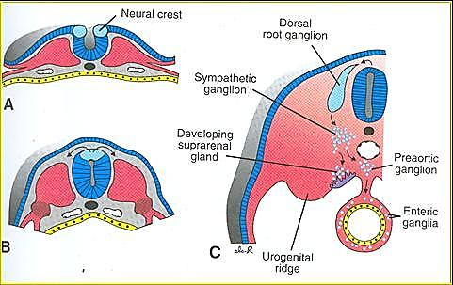

Neural crest derivatives
Cranial neural crest cells | Vagal neural crest cells | Trunk neural crest cells
- Parasympathetic ganglion of III Cr. N  - Muscles of iris and ciliary body  - Part of cornea  - Odontoblasts of teeth  - Parafollicular cells of thyroid  - Cranial nerve ganglia (+ all glial cells) of V, VII, IX, X Cr. N  - All postganglionic neurons + glial cells of Parasympathetic ganglia of Cr. Ns VII, IX, X  - Piamater +  - Arachnoid mater  Cartilages of branchial arches  - Meckel's cartilage  - Reichart's cartilage  - Laryngeal cartilages | - Aorticopulmonary septum  - Enteric nervous system  - From oesophagus to rectum  Contribute to parafollicular cells of thyroid | Peripheral neurons  - Peripheral sensory neurons  - Cell bodies reside in dorsal root ganglia  - Sympathetic  - Parasympathetic  - Enteric neurons  Dorsal root ganglia  - 7 cervical (pairs)  - 12 thoracic  - 5 lumbar  - 5 sacral  - 1 coccygeal  Sympathetic ganglia  - 3 cervical (pairs)  - 12 thoracic  - 5 lumbar  - 5 sacral  - 1 coccygeal  - Inner and middle meningeal coverings of spinal cord  - Schwann cells of peripheral nerves  - Neurosecretory chromaffin cells of suprarenal medulla  - Melanocytes

Neurocristopathies
Are neural crest diseases
- Neurofibromatosis (Von Recklinghausen disease)
- Charcot – Marie tooth syndrome
- Waardenburg type 1 and 2
- Pheochromocytoma, Hirshprung’s disease, albinism, CHARGE syndrome

